Student’s name | …………………………………………………….…… | Grade | 1
Subject | Computer | Week No. | 6
Lesson Title | Introduction to Multimedia | Unit
Worksheet No. ( 6 ) (Answer)

Question A: write the correct name of each part

Smartphone | Web camera | Video Camera
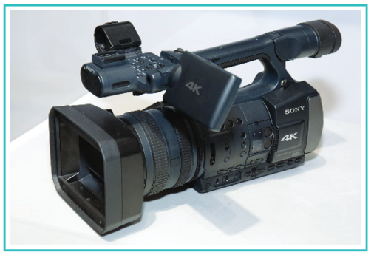
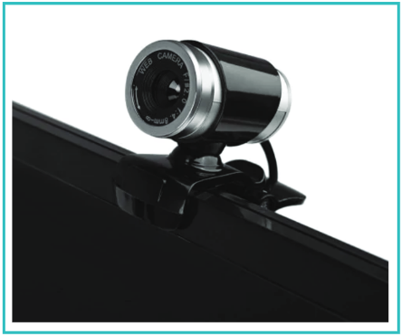

Web camera
Video Camera
Smartphone
Good Luck

